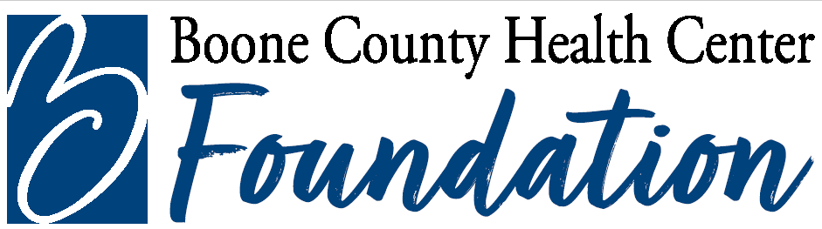

2025 Guidelines for Babcock/Buckles Advanced Nursing Scholarship

Goal
Advance education of current nursing staff at Boone County Health Center and Wolf Memorial Good Samaritan Society –Albion.

Guidelines for selection

- Recipients shall be current employees of Boone County Health Center or Wolf Memorial Good Samaritan Society-Albion who are seeking additional schooling in the nursing field.

- Recipients must also have at least 2 years of nursing training or the equivalent and now be pursuing a Bachelor’s Degree, Master’s Degree, or additional college credits in the field of nursing.

- $2,000 will be awarded for the school year ($1,000 per semester). Money must be spent on tuition or books for the upcoming school year. Recipients may not use the grant to pay for the necessary pre-requisite courses to become eligible for a program of study.

- Recipients may reapply for a grant and shall be considered on the same basis as other applicants.

- Recipients shall express and demonstrate an interest in continuing to live in Boone County Health Center’s seven-county service area.

- A selection committee appointed by Carol Buckles shall consist of Medical Staff Member, Dr. Joel Travis; BCHC Director of Nursing and Director of BCHC Foundation.

- Must be for future schooling, not for classes already completed.

Administration of Scholarship

Scholarship will open May 30, 2025; application deadline is Aug 29, 2025 and the scholarship will be disbursed by Sept 30, 2025. Recipient must provide proof of enrollment with application.

